NAME……………………………………………………………………………………………………………STREAM…….……………

Signature ………………………………………………

**LIGHT ACADEMY SENIOR SECONDARY SCHOOL**

**BEGINNING OF TERM III EXAMINATIONS 2023**

**S2 CHEMISTRY Paper 1**

**Time: 2 hours**

**INSTRUCTIONS;**

* **Use a ballpoint pen**
* **Attempt *ALL* the questions in the paper**
* **Diagrams where necessary must be drawn using a sharpened pencil.**
* **Read each question frequently and carefully before answering**

1. You are a science communicator invited to give a presentation at a local high school about the significance of the periodic table in understanding the behaviour of elements. Your audience consists of students who have just started learning about the periodic table.

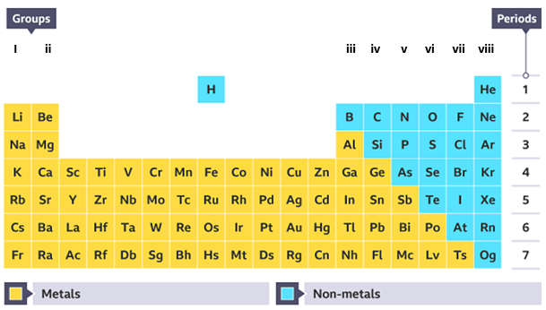

Your goal is to explain the organization of the periodic table and its relevance in predicting the properties and reactivity of elements.

* Introduction: Briefly introduce the periodic table's significance in chemistry.
* Organization: Explain how the periodic table is organized, including periods, groups, atomic numbers, and atomic mass.
* Predicting Properties: Discuss how the periodic table helps predict element properties and reactivity based on their position.

2. The Ministry of Health annual reports recorded that 60% of Ugandans fall sick every month of which 40% of those who fall sick suffer from typhoid of which 95% of the people who suffer from typhoid are attributed to unclean water.Top of Form

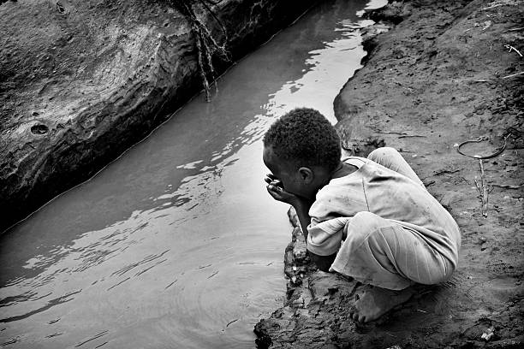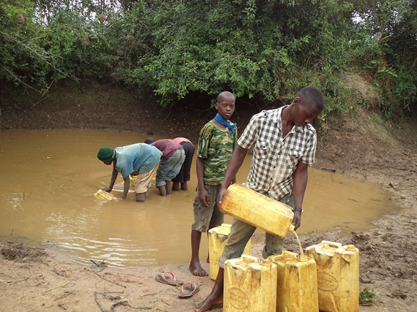

Task: As a chemistry student, write an article guiding the citizens on how to solve the water problem.

3. Charcoal is a fuel used in most homes throughout the country. Some people and NGOs are always against the business of charcoal because of the effect that it leaves on the community and community members feel so bad whenever they are advised to stop using charcoal fuel since most of them consider it as a cheap form of fuel. It has been branded that charcoal burning is another big war taking place in the country

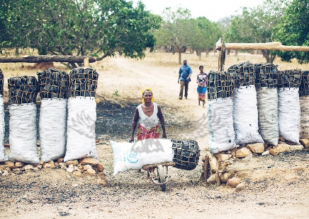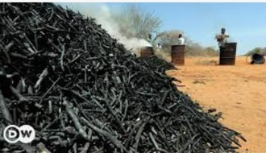 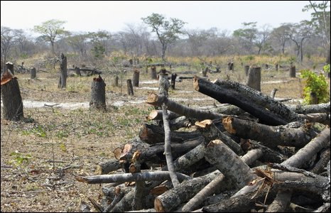

Write an article to be published so that they can use it to educate and sensitize the citizens.

4. You are a student in a geology class, and your teacher has assigned you the task of giving a short speech to your classmates about the rock cycle. The goal is to help your classmates understand the basic concepts of how rocks form, change, and interact in the Earth's processes.

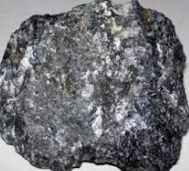  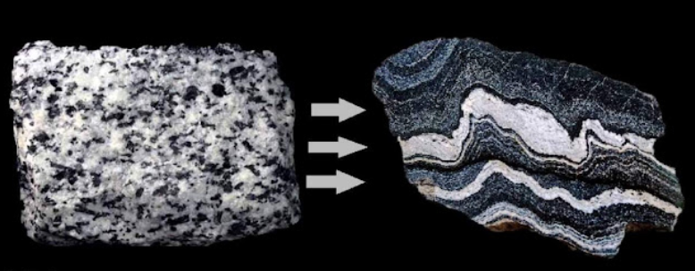

Task; prepare the speech.

The following are the key points you are supposed to emphasize in your speech:

* **Formation of Rocks:** Explain how rocks are initially formed, including the three main types and some examples.
* **Rock Cycle:** Describe how rocks can change from one type to another over time. Illustrate the continuous cycle in which rocks go through these processes.
* **Importance:** Explain why understanding the rock cycle is important for geologists and how it connects to our everyday lives

***success***